Loan Default Project
Project Goal: Predict whether a person will default on loan or not, based on the given attributes.
Chosen model: Optimized Random Forest
Final accuracy: 91%
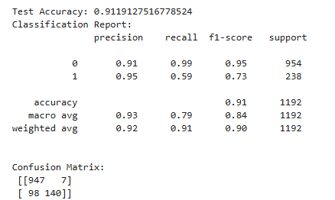
Insights From EDA:
For Categorical Variables(JOB & REASON): -
- The self-employed persons who have taken debt to repay other existing loans are most likely to default (47%).
- The persons who are involved in sales job have a higher chance to be a defaulter irrespective of the reason of taking loan. (35% & 33%)
- Managers who have taken loan for home improvement are considered as risky loan taker.
- But the office goer (admin or desk-based task) or professional or executives (high-skill persons) are less likely to be a defaulter.
For Numerical Variables: -
- All the numerical values had few outliers, treated them with DBSCAN method which helped me to keep useful information while removing extreme outliers.
- Scaled down all numerical features to get balanced contribution from each feature stable gradient behavior and reduced impact of extreme values.
- Noted most important features which contributed most in the model performance and can be considered as one of the KPIs.

